Official World Axe Throwing League Game VGTD, triOs College 2018

**horizontal line**



The Official World Axe Throwing League (tentative title) will be among the first of its kind: an axe throwing game that represents the official sport itself. This game will be primarily a swipe-based 3d action ‘sports’ game that is aimed toward the “everyone” demographic.

The intended systems for this game will be limited to the mobile operating systems of iOs and Android. This is a game specifically targeted toward the “pick up and play” stylization of games in order to maximize downloads and consistent playership among mobile gamers.

The projected shipping date for this game is within 2 months, with a dev team of 3, and 1 artist.

**Gameplay Modes -** There will be 1 mode to begin with. This basic game mode will involve swiping in two directions, down (to build power for trajectory and power) and back up to release the axe. The goal of this game is to stick the axe within the rings and get the highest score with 5-10 shots. After the player has run out of axes to throw, they will either move on to the next level, or start over at that same level. If a player fails a level 3 times (the lose all 3 “lives”), they must start over from the beginning of level 1. After successfully completing 3 levels in a row, the player will receive another “life”. This will continue up to 5-7 levels to begin with, with the goal of an endless level option.

**Unique Selling Points -**  This game is unique in itself, in that there are no similar games of this particular style. The goal with this game is to create a game that is both a long term investment of time, and a pick-up-and-play simultaneously.

**Competition -** There is no current competition for the niched sport/action game, except for 1. This game is called “Axe Champ” and is a “free” game on the iOS store. While it is addicting, it lacks the features, 3D nature and official support of the World Axe Throwing League.

There is an unbelievable amount of potential for feature updates/upgrades for this game. For example, a scoring system that may award players with different environments, and axes (maybe even unlock knives, etc?). In addition to that, there may be areas for additional game modes such as: monster survival, pvp and more!

**Challenges for the Player -** Obstacles that players may overcome include:

* Opposing players in a set-number-of-throws face-off for points
* Opposing computer controlled players in a set-number-of-throws face-off for points
* Moving targets

These will be solved by the refinement of the art of the swipe, in addition with power-ups like:

* Buckshot axes (1 axe splits into 3)
* Double points on whatever ring the axe lands in

These power-ups will be collected by hitting 3 bullseyes in a row.

**Progression**

The progression will go forth as game mode, skins and environment become unlockable by level. These have yet to be determined but it will likely be every 5 levels. Every 100 points collected total will equal a progression of 1 level. If the player loses whatever game they are in when they collect the points, their total points are **halved** *(offline mode only)*

There may be titled ranks by level prestige (every 100 levels).

The gameplay will also feature a story mode (to be implemented in future updates, not on release) that follows the player starting off as a rookie axe thrower to eventually going to the World Championships. It will feature all of the environments with an added storyline that is to be written by some of the members of the WATL itself.

The story will encompass all of the game modes, power ups and levels into a comprehensive game mode that will reward the player with an endless chance to grind for higher levels, which, in turn will unlock new axe styles and game modes.

Since this game mode playstyle will emulate a real life tournament, there will not be any bosses, as progression cannot continue so long as they player loses. During the story mode, the player will experience 5 ‘games’ in each environment. If the player defeats the computer in each of these ‘games’, the player will advance. If the player loses at any point to a computer in a single environment, the player will start back at the beginning of that environment.

**Victory Condition**

In most game modes, the player will have 20 throws against any opponent. Whichever axe thrower gets more points within that amount of throws, wins.

As this will be an Official game of the World Axe Throwing League, the scoring system will follow the real-life rules:

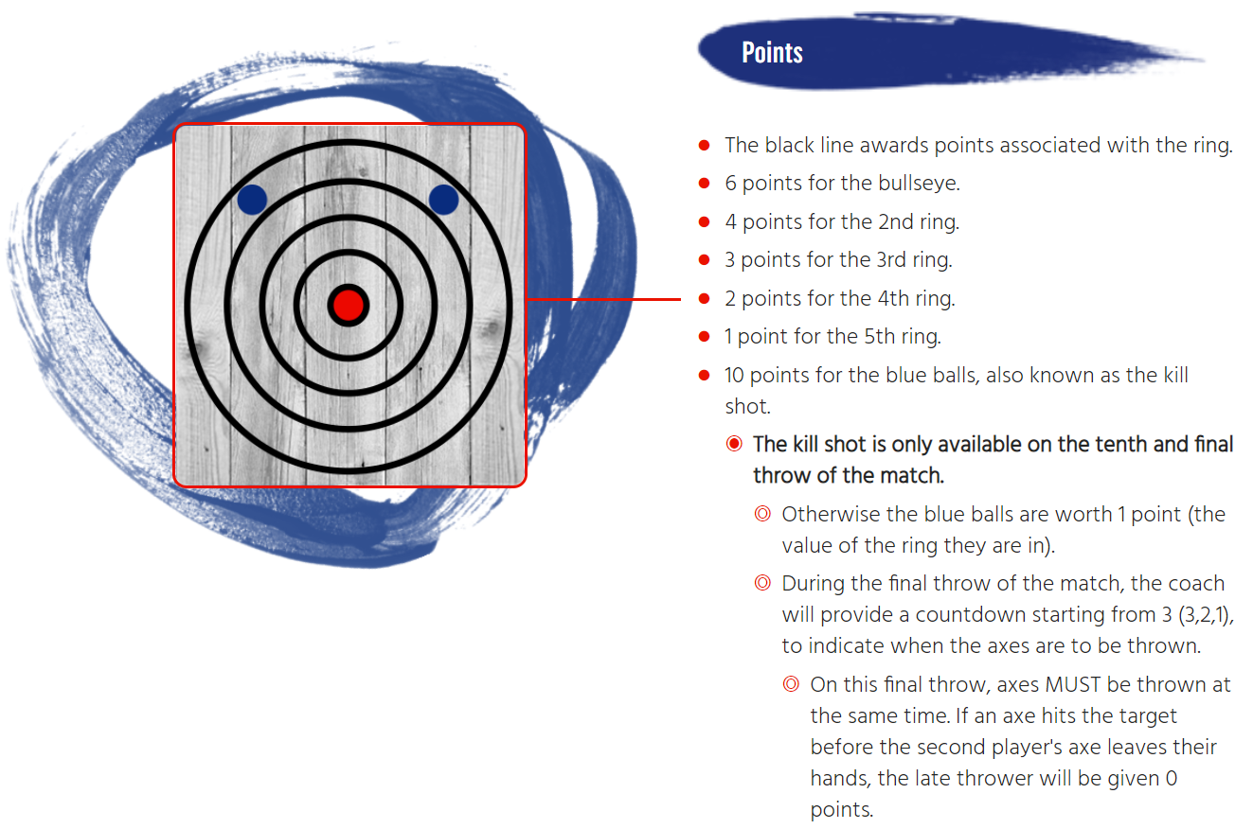

**Within the Game World**

The game world takes place on earth, and mimics the real world’s gravity, and general environment.

The environments featured on release of this game will be:

* Forest
* Toolshed
* Field
* Axe Throwing Facility (x2)
* Axe Throwing Facility (with spectators)
* Small Stadium
* Olympic Stadium

The music used through the game will be of a electric rock/metal genre, originally composed by Ryan Vencer.

**Game Experience**

When the app is opened, in order of succession, the player will see the following:

* The WATL logo
* The Game Studio’s Logo
* The unreal engine logo?
* The main title
* The menu (3D world)

This game is intended to provide an environment of excitement, commitment and focus.

The music and sound will provide a level of badassery that will set the tone for the sport, followed with very light screenshakes and lighting effects for special hits (such as the bullseye or the killshot)

**Gameplay Mechanics**

**Mechanics**

The level of gameplay is fairly simplistic; it is quite akin to the playstyle of any other quick action game. Pick up and go is a common theme with this game.

To throw the axe, the player will swipe down, then back up. Where the player’s finger leaves the screen is the point of which the axe will be flung from the first person view, at a set trajectory toward the target *(or toward the sky depending on the swipe)*. Once the axe hits the target, a collider on the blade will trigger the axe to freeze the axe’s position at point of contact with the target. If any other part of the axe hits the target, the axe object’s physics will be turned on in order to simulate a true improper throw.

**Hazards**

As this is a sports game, the only way for a player to lose is to not make enough points to beat their opponent.

At this time, there are no plans to include any detrimental hazards to any game mode.

**Power Ups**

The power-ups from launch will be simple, and minimal. As the game ages, there may be cause for additional power ups in the future.

As mentioned previously in this document, the only power ups will be as simple as the game itself:

* Buckshot - 1 Axe splits into three that spread out equally and add to the player’s points for that throw.
* Double points on whatever ring the axe lands in.

These power-ups will be collected by hitting 3 bullseyes in a row.

**Collectibles**

Collectibles may be implemented throughout the tentative story mode, as items that randomly spawn during a single environment.

Collectible concepts include:

Axe Skins

Avatars

**Enemies**

Each face-off in Tournament Mode, Story Mode or Multiplayer mode will consist of going in a head-to-head throw off against either a computer or human player.

These *(non-player)* Enemies will have AI script written for them in incremental levels. As the player progresses, the “randomization” of the AI’s throws will reach values of a more precise nature, thus increasing the difficult of the AI as either the

* Player grows in experience (via tournament) or
* Player sequentially progresses through each chapter of the plot (story).

There will be boss characters, only in the form of the final thrower to face per chapter (story).

In future iterations of the game, bosses may have a trick shot lightning round. In this round, the gameplay style will change.

This trickshot mode will require the player to drag their finger in a specific pattern in order to execute the trick shot.

This will be similar to the pattern unlock function in smartphones:

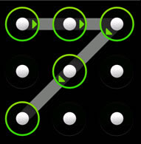

The player will first choose what number (ring, bullseye or blue dot) they will aim for. Depending on what they choose, the pattern will be complex and may even have multiple patterns to complete.

The accuracy of the throw will be determined by the accuracy of the finger being dragged, and the success *(if any)* of the throw will be determined by the speed of which it is completed. For example,

If the player wanted to hit a bullseye in the trickshot round, they would need to be nearly perfect with their finger swipe accuracy and also complete the pattern(s) within the specified time.

**Multiplayer**

There are plans to provide a multiplayer mode in which the players may do the following:

* Create an “Axe Thrower” profile
* There will be a multiplayer tournament which will include scores compared internationally within the player base. This will be the worldwide ranking.
* Tournament set-up and rules will again, mimic the real thing:

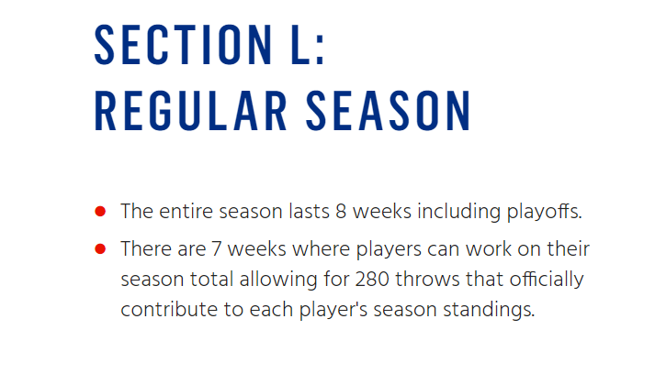

There will be 4 Tournament Seasons to begin with. *(Spring, Summer, Fall, Winter)*

During each of these seasons, to maintain playership, the game will separate from the real tournament rules in that it will merely take the average of every game played in Tournament mode and will calculate a player’s rank/score from that.

In addition to the seasonal tournament mode, there will be regular face-off play against randomly matched up opponents. In this mode, trickshot mode will be active.

**Bonus Materials**

Bonus Materials will include:

* Collectible Axes
* Championship Cards
* Achievements - TBD
* Axe Types and Skins
* An Axe Store *(uses in-game currency)*

**Monetization**

This game will start off being $0.99 and may increase over time due to popularity.

The Official WATL Game will not be play-to-win. Every player will have an equal opportunity to win, regardless of what axe they are using.

Throughout play, alongside experience, players will receive a set number of “WATL Bux”. These WATL Bux will be able to be used on avatar customization, axe skins and types, particle effects, and eventually new game modes.

On that topic, new game modes will be billed as DLC.

The uncommon difference in how this game will handle DLC is that if players want to grind and accumulate a significant amount of “WATL Bux”, they will be given the option to spend this in-game currency on things that are industry-typically only purchasable with real world currency.

Any in-app purchases made will be instantly converted to “WATL Bux”.

**Marketing Feasibility**

This game is taking full advantage of the trend that’s happening in the real world, and capitalizing on it.

As such, there is little marketing to be initiated by the studio.

The WATL itself is an instant brand.

**Complexity of the Game**

This game is very bare-bones. It’s for a reason. If the app(game) is clogged with too many features, it will take away from the pick-up-and-play market that it is intended to be catered to.

Other game modes and features will be developed over time, pending the success of this game, but before that it will be quite limited to ensure that downloading and loading times are as small as possible.